All-Age Zoom Energise 21st February 2021
Come and follow me
Our story today is about Jesus calling some of his disciples – Val put it together using a combination of the following Bible passages:
John 1: 35-42, Luke 5: 1-11, Mark 1: 14-20, Matthew 9: 9-13 and Mark 3: 13-18

Our memory verse today is: Matthew 4: 19
which traditionally says ‘Come, follow me,’ Jesus said, ‘and I will make you fishers of men.’
or if you want to be more inclusive ‘Come, follow me,’ Jesus said, ‘and I will send you out to fish for people.’

Our craft today reminds us that Jesus calls us to follow him.
We’re making a pair of flip-flops – which we can wear, or hang up in our house, to remind us to follow wherever Jesus leads.
You’ll need:
- Some strong cardboard, (if you want to be able to wear them properly use foam sheets, or leather)
- Some ribbon or tape or string or elastic – you can decorate this if you want to (maybe with beads)
- Some strong glue and sticky tape
- Something to make a hole and something to cut a slit
1. Draw round your feet onto the cardboard (or foam or leather). Now draw a shoe-shape outline around your foot shape – about ½cm bigger than your foot
2. Cut out 2 for each foot – one for the top and one for underneath
3. Mark with a pencil, on the top one, between your biggest two toes and either side of your foot just in front of your ankle.
4. Make a hole where you’ve put your mark between your toes, and make a slit where you’ve made the other two marks.
5. Fold your ribbon in half and push the fold through the hole. Secure it temporarily, so it doesn’t come out (if you’re putting beads on it you need to do it now) and then thread each end into a slot from the top down.
Check that you can get your foot in and pull it to the correct tightness and then tape the ribbon underneath near the holes to stop it moving. Then secure the ribbon by threading the ends through the loop, pulling tight and then taping the ribbon. The glue should also help secure it (6).
6. When you’re happy that the ribbon feels right and it is properly secured, glue the bottom part of the sandal to the underneath of the top part, covering the loose ends of the ribbon.
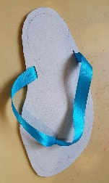
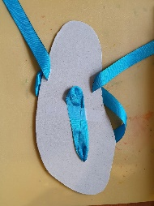
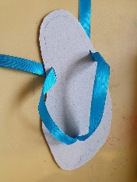
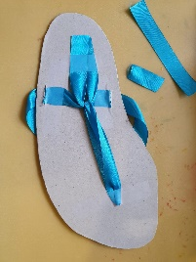
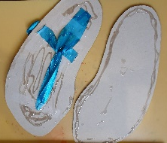
7. Repeat for the other foot – and you have a pair of flip-flops!
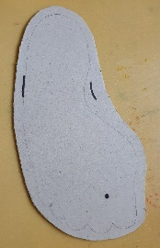
5
5
1-3
6

